Practical - 5
Practical Title: Registration Form with Frontend Validation and User-Friendly Error Handling

Problem Definition : Create a student registration form with HTML5 input types and JavaScript validation for name, email, mobile number, password, confirm password, course, year, gender, and terms acceptance. Use Regular Expression for validations.

Theory
1.Are correct input types and attributes used?
Yes, correct input types and attributes are used for each field.

2. Are validation errors displayed near the relevant fields?
Yes, validation errors are displayed near the relevant fields.

3. Is password strength checked?
Yes, password strength is checked using suitable rules.

4. Is the form accessible using keyboard and screen-reader-friendly
labels?
Yes, the form is keyboard accessible and uses proper labels for screen readers.

Evidence of Work (Screenshots):
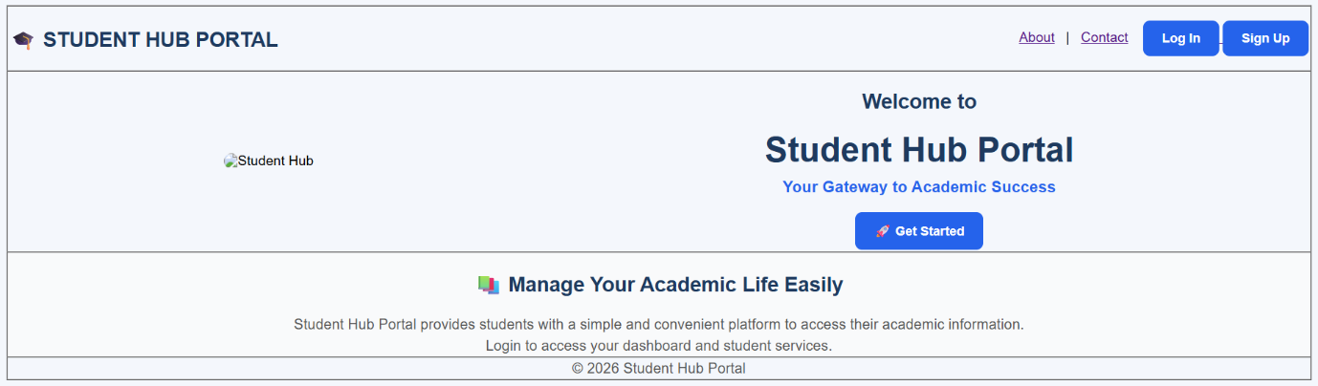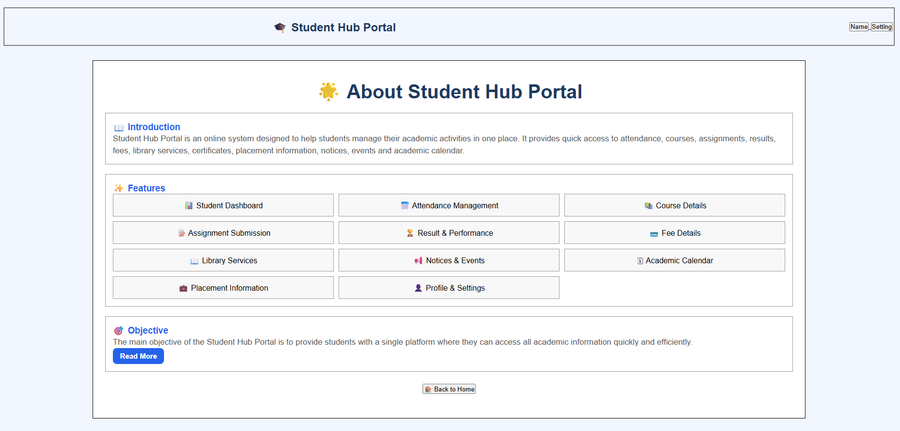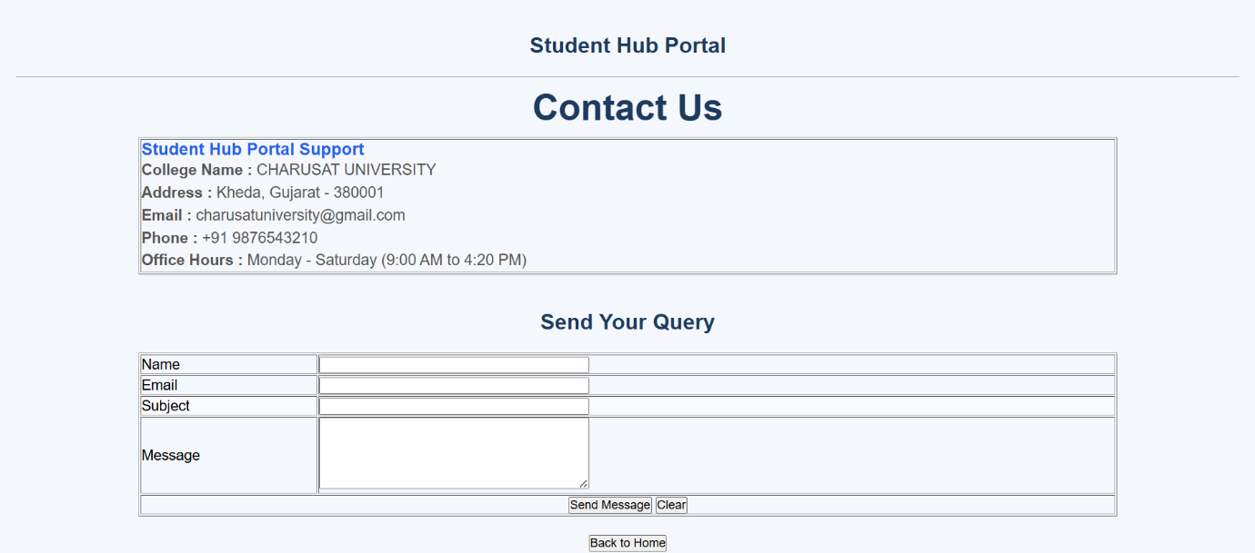
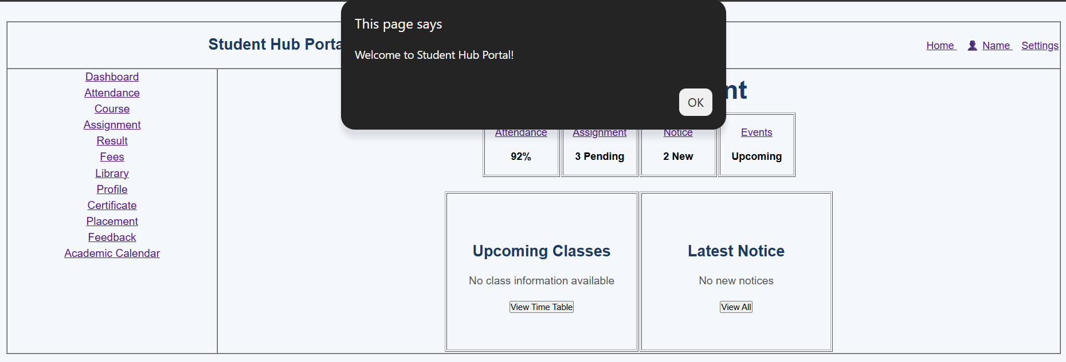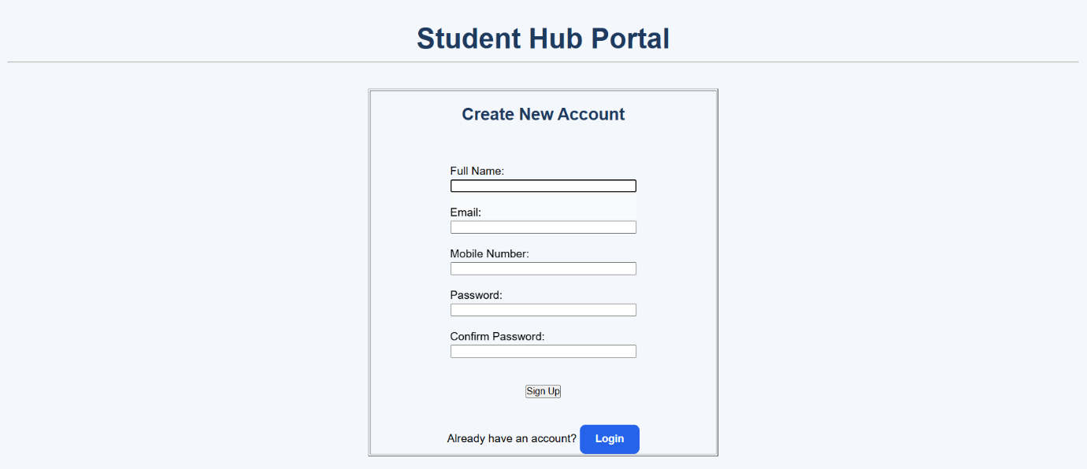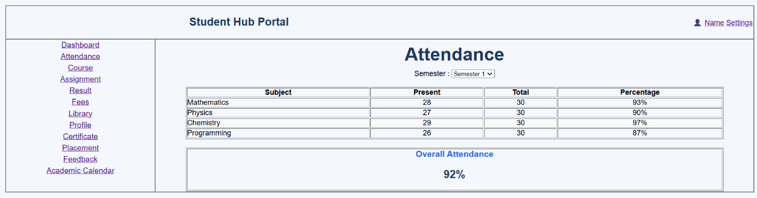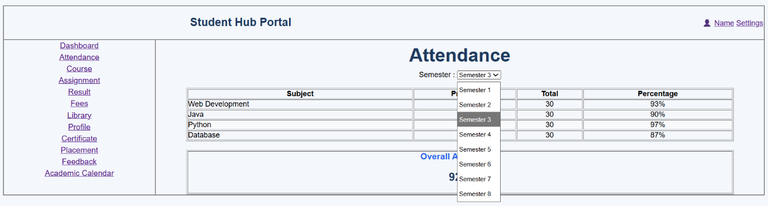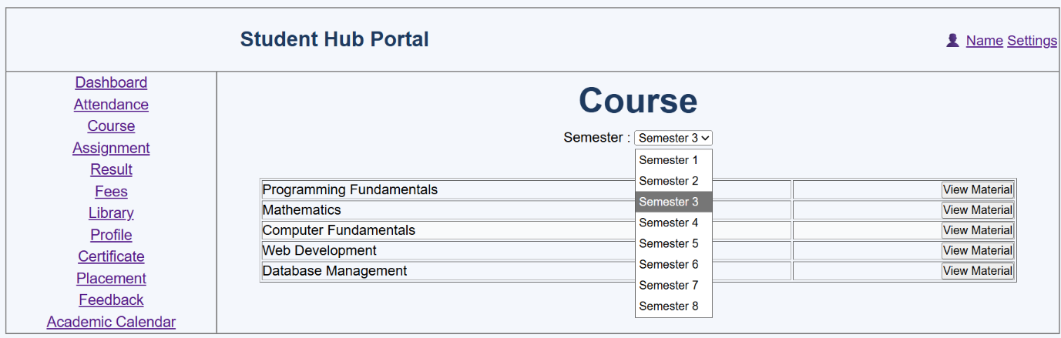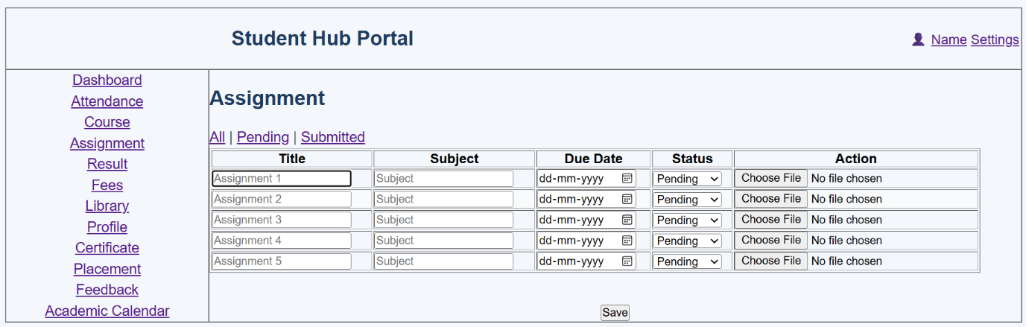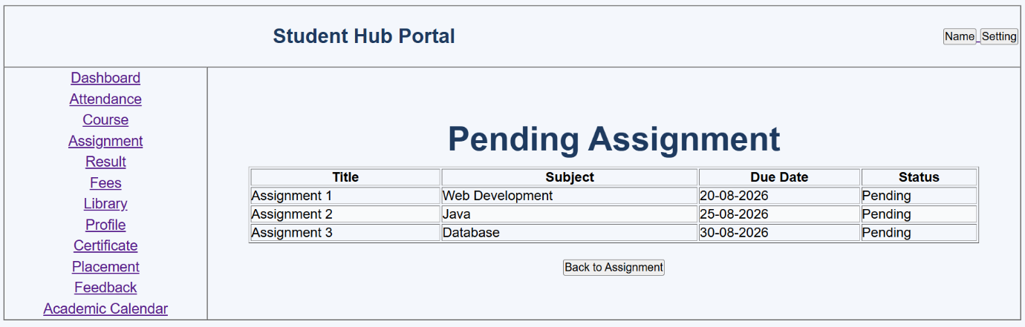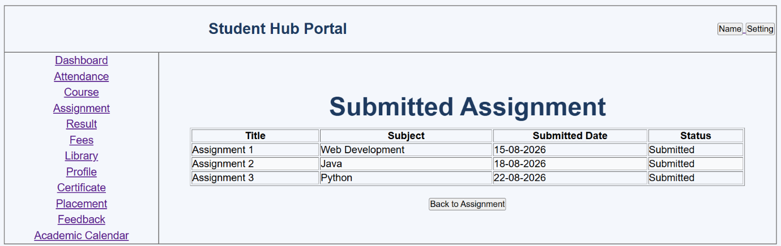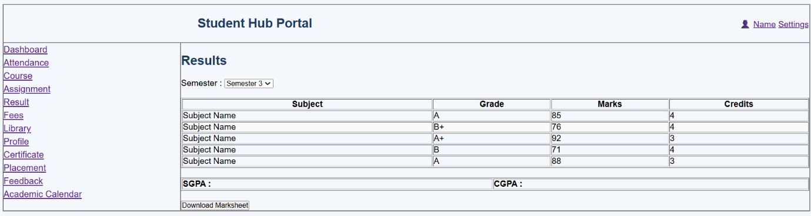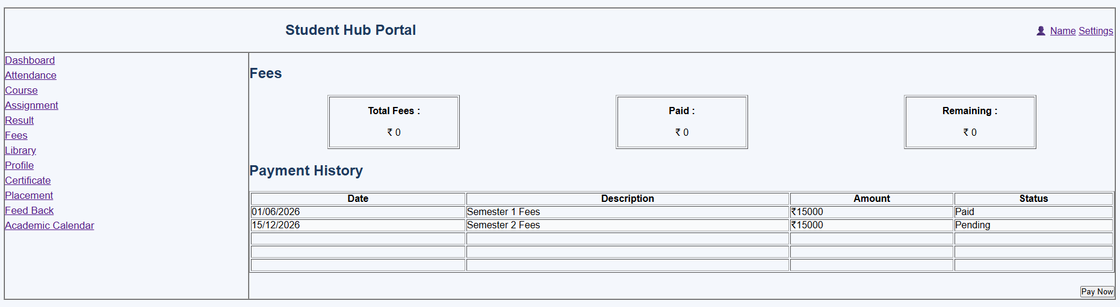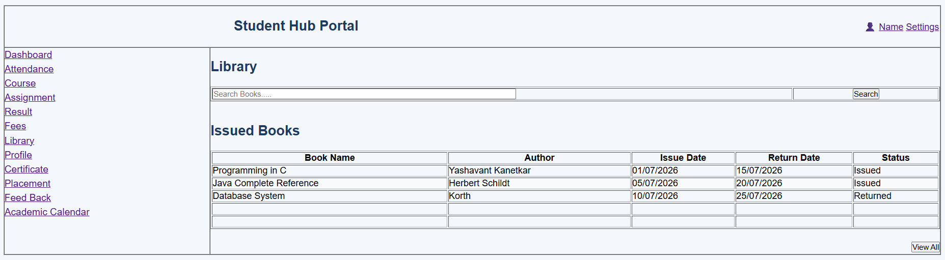
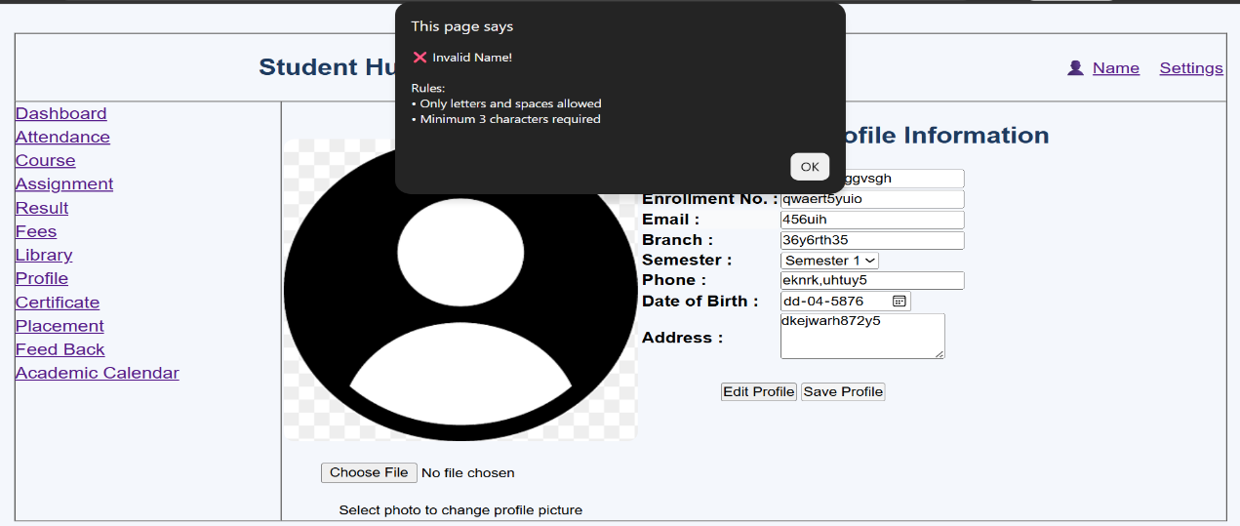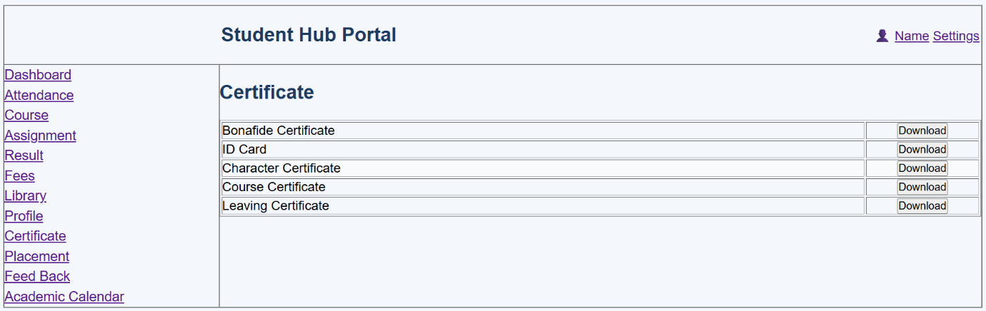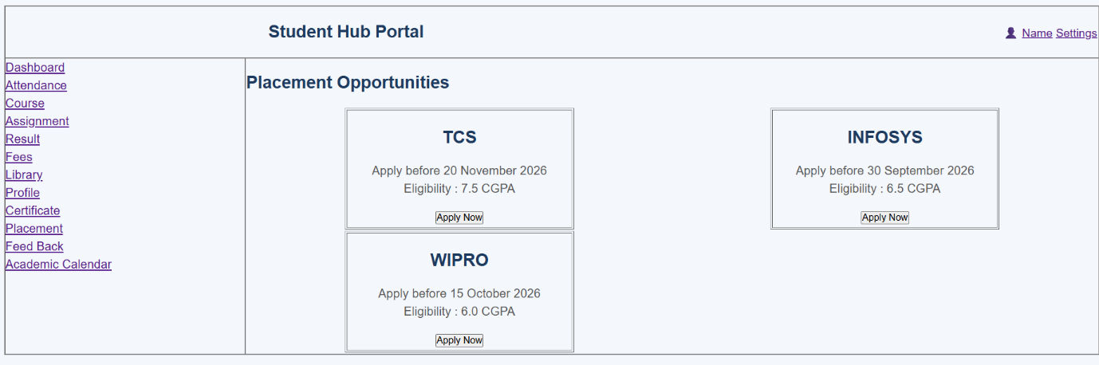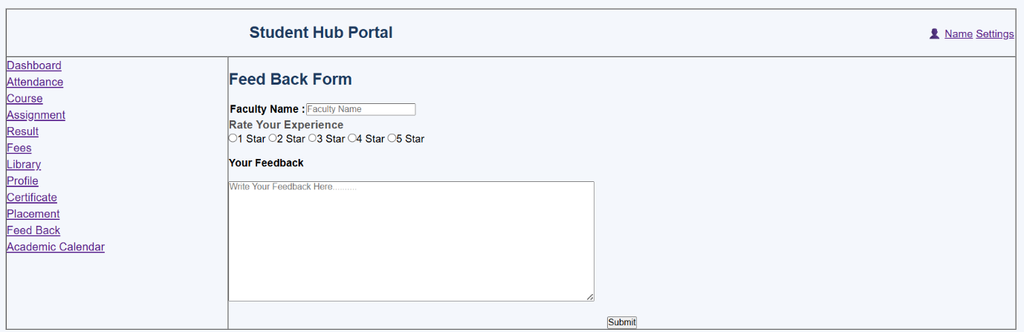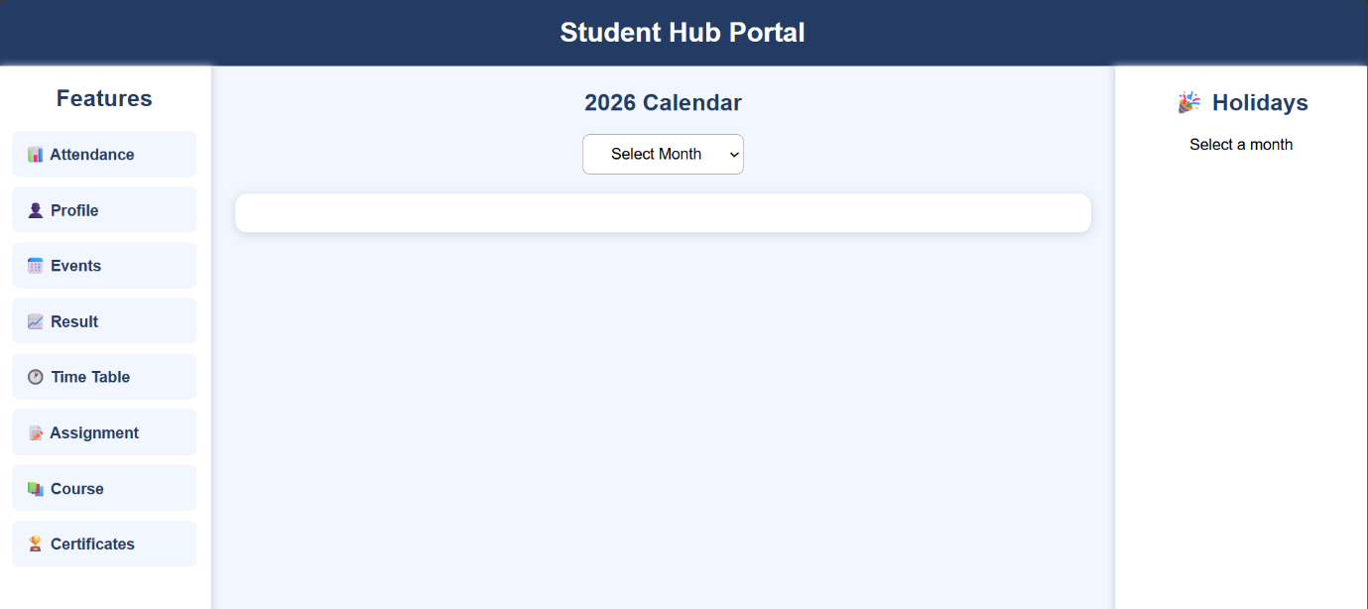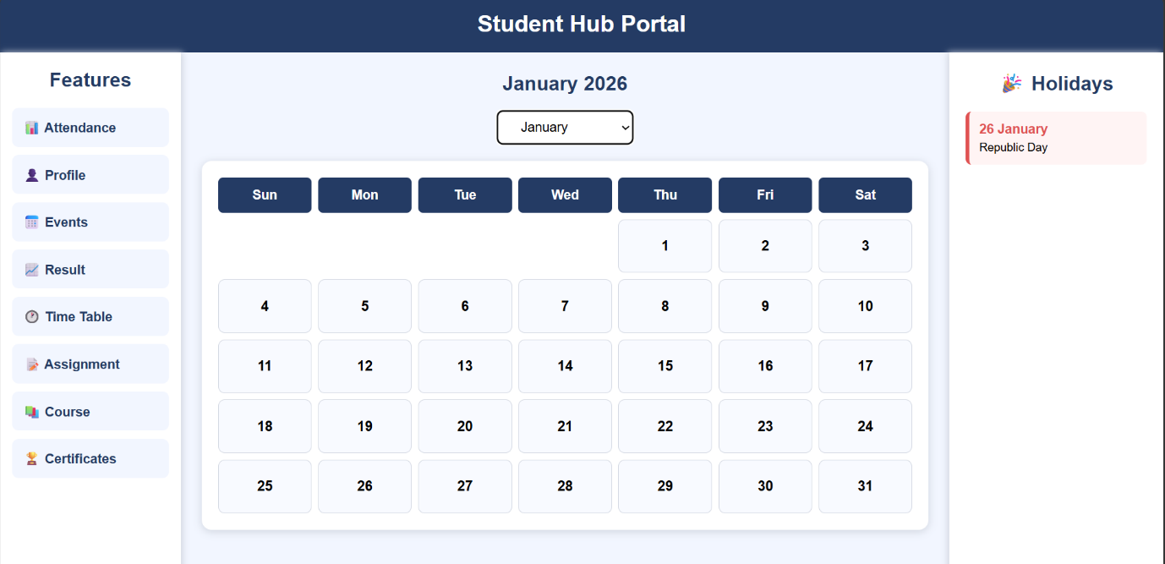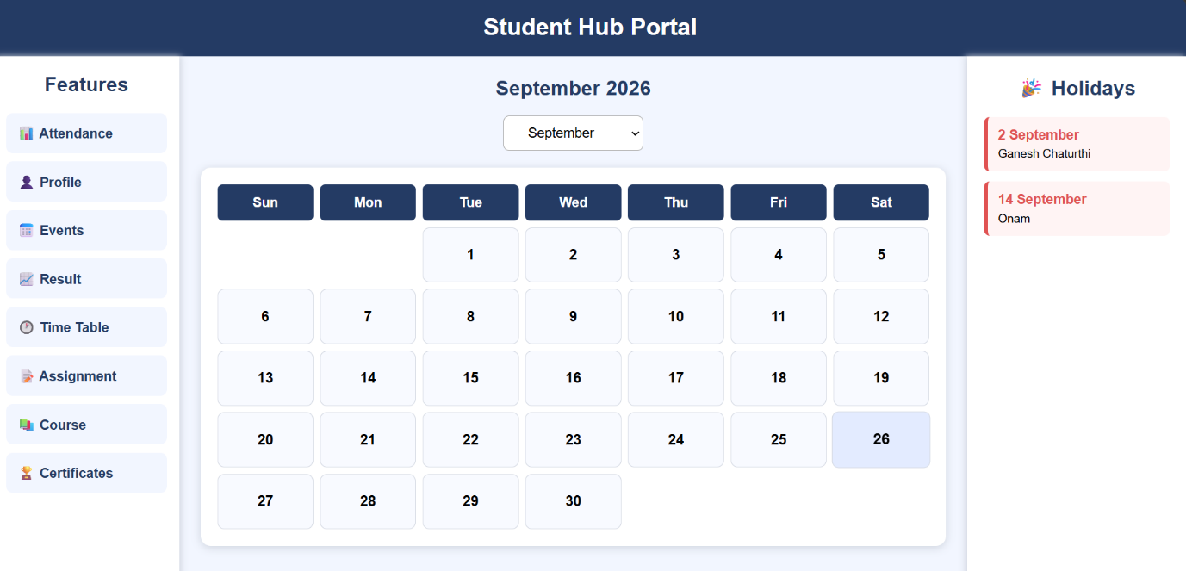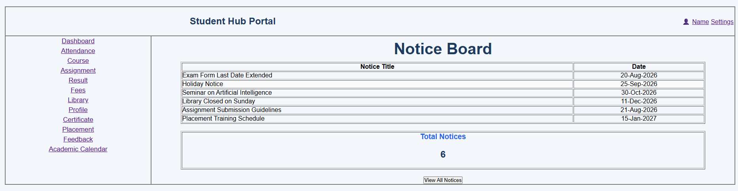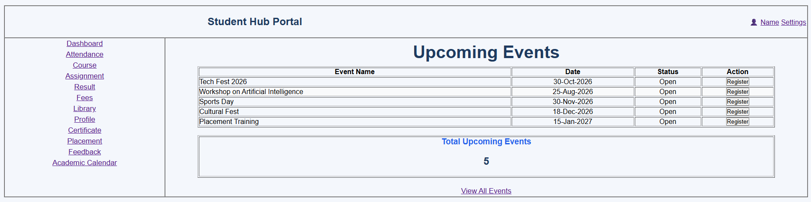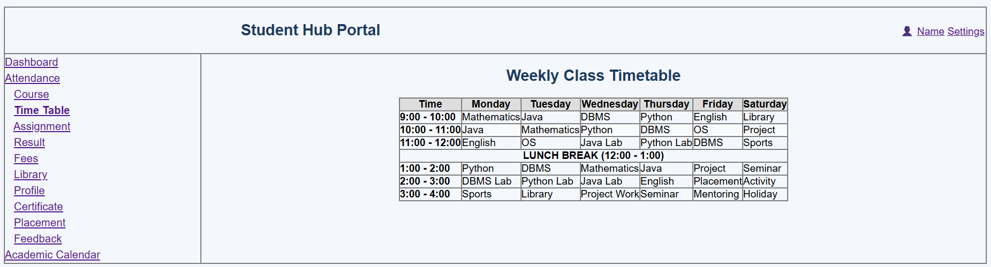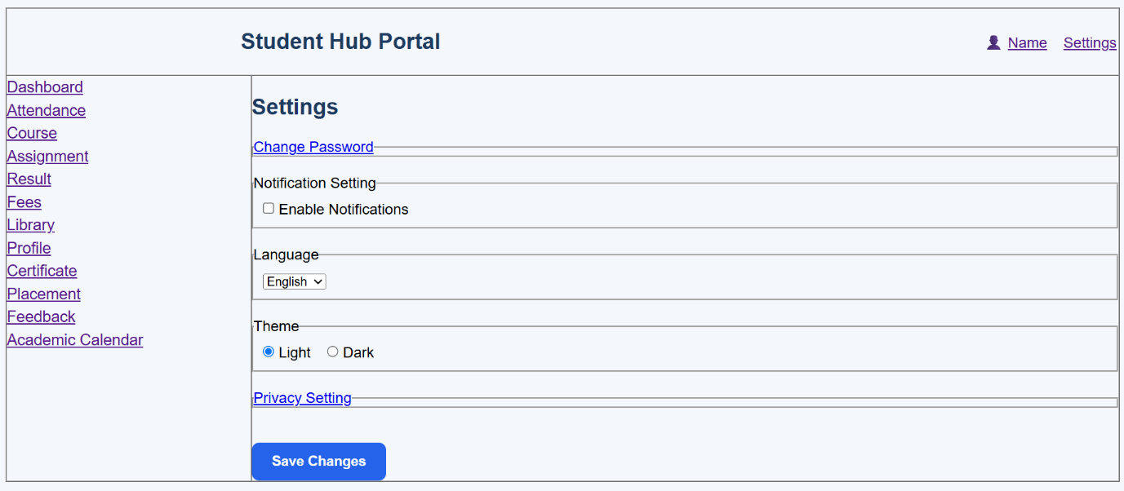

GitHub Repository Link:

https://github.com/Andarpadhruvi1125/Student-Hub-portal.git

C. Challenges Faced:
I faced some difficulty while designing the registration form and making it responsive on different screen sizes. Applying JavaScript validation for name, email, mobile number, password, and other fields was also a little challenging. Understanding Regular Expressions and showing proper error messages near the fields required some practice.
D. Learning Outcomes:
I learned how to create a student registration form using HTML5, CSS3, Grid, and Flexbox. I also learned how to make the form responsive and user-friendly. Through this practical, I understood how to use JavaScript and Regular Expressions to validate different input fields and improve the overall form functionality.

Faculty Remarks: (Keep this blank for faculty)

